Risk Register and Management Plan Template

Template
Risk Description |  | Risk Assessment |  | Monitor and Manage
 | Risk | Potential Impact | Likelihood | Risk Management Plan | Owner | Status

Risk Identification and Assessment
Risk is the possibility that a negative event will happen. It is important to plan for events before they happen to give you the best chance of achieving your objectives. It is important for Nations to know what the potential risks are and to create the right strategies to deal with them.
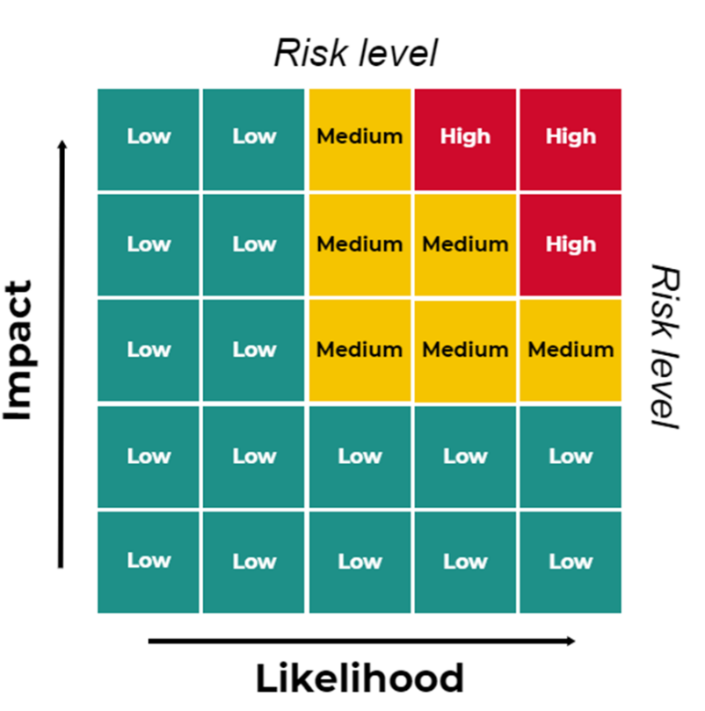
Not all risks are equal or easy to predict. Organizations need to assess the likelihood and the potential impact of each risk to identify risks as:
- Low Risk
- Medium Risk
- High Risk
An organization can assess each risk by scoring two risk factors:
- The likelihood of a risk occurring
- The impact a risk would have if it occurred
By assessing each risk, a Nation can prioritize the risks and create a risk management plan for the medium and high risks. The risk management plan may include the following risk treatment strategies.
- Risk avoidance: make changes to avoid risk entirely
- Risk mitigation: activities to reduce the likelihood of the event happening
- Risk transfer or sharing: may include insurance or partnership to reduce risk
- Risk acceptance: when no action is possible or required

Risk Themes
Risk management is an important part of FMB Standards. Standard 20 in our FMS Standards (B2) requires that a Nation consider the following financial risks in a risk management plan:
- Fraud
- Financial reporting
- Investments and for-profit business activities
- Insurance
- Loans, guarantees, and indemnities
- Emergencies
- Technology

Sample Risk Management Plan
Risk Description |  | Risk Assessment |  | Monitor and Manage
 | Risk | Potential Impact | Likelihood | Risk Management Plan | Owner | Status
1. | Investments and For-Profit Businesses (required)  No rules to guide investments and for-profit businesses by the Nation, according to the FAL | Medium-High | High | Council makes all major decisions. Create corporations and assign Council and external parties (business professionals) for Board of Directors. Nation’s financial institution manages portfolio investments and provides monthly reports to Council. Develop rules and policies, according to the FAL.
2. | Loans Guarantees and Indemnities (required) | Low | Medium | Council does not loan to members or provide guarantees until developing rules around loans, guarantees, and indemnities, according to the FAL.
 | Council does not enforce or have rules to govern loans, guarantees, or indemnities, according to the FAL
3. | Insurance (required)  No documented or appropriate insurance coverage | Medium | Low | Insurance policy instated and reviewed every year.
4. | Emergencies (required)  No emergency and contingency planning | High | Medium | Develop emergency plan. Have business continuity plan.
5. | Financial Reporting (required)  Lack of rules to govern financial management, according to the FAL | Medium | Low | Have approved policies, according to the FAL. Enforce policies and require regular financial reporting.
6. | Fraud (required) | Medium | Low | Have approved policies, according to the FAL. Have FAC and have independent Board of Directors for for-profit businesses.
7. | Technology (required)  Do not have appropriate information technology systems and controls | Medium | Medium | Outsource to IT service company and have them handle all network security and back-ups.
8. | Grant funding dependence  Funding shortfall due to the grants stopping | Medium | Medium | Develop other ways to fund the programs and use a portion of OSR for core cultural programs.
9. | Language loss  Not recording our stories and language | High | High | Language Project approved and in progress
10. | Knowledge loss  Lack of succession plans | Medium | High | Electronic content management; mentoring program; succession and recruitment planning
11. | Health and Safety of staff (Critical incident)  Staff member injured on-site or in the function of their duties due to a critical incident | Medium | Medium | Create Health and Safety Committee to identify and manage key issues
12. | Unsafe/ inadequate infrastructure  Delaying infrastructure/asset maintenance | Medium | High | Develop tangible capital assets plan to assess and schedule maintenance of assets, including infrastructure
13. | Poor health outcomes  Members not participating in exercise programs | Medium | Medium | Start health awareness campaign. Have strategies for engaging various demographic segments. Assess causes of poor health outcomes and address through long-term planning.
14. | Lack of funds required to achieve strategic priorities  Not linking cultural values to economic development activities | Medium | Medium | Develop economic development plan based on community’s long-term goals, cultural values, and unique market opportunities.
15. | Educational outcomes of members do not support sustainable jobs  Our youth do not graduate | High | Medium | Develop education program that is culturally relevant and based on world-leading education principles. Work with regional and international partners.

Sample Organizational Risks
Nations may be interested in managing broader organizational risks as well as financial risks. To assist with your conversations about risk and with the population of your risk management plan, consider the list below:
Risk Management Theme |  | General description of why it is important | Example of why it may be important to you | Can include consideration of risks related to:
1 | Financial Management | It is vital to have the right level of controls in place to manage your organization and community's finances. | Lack of effective financial management will limit our ability to become independent | Investments, policies and procedures, fraud, risk management, decision making
2 | Skills and Capacity | Every community needs to grow its capacity and invest in the skills needed to move that community forward. | Without skills and capacity, we will not be able to manage our services and improve our future | Succession planning, training, traditional vs non-traditional training, leadership
3 | Governance | Decision-making, operational, and financial management has to be underpinned by robust governance procedures, policies and controls. | Without effective and transparent governance, we will not be able to prioritize activities and build a strong Nation | FAL, leadership, strategic direction, decision making, transparency
4 | Stability and Inter-Government Relations | Every community needs to have stable leadership and needs to interact with other governments in a consistent and effective manner. | Without positive and effective relationships with partners and other governments, we cannot grow economically. | Partner relations, reputation, agreements, own-source revenue
5 | Land Protection and Environment | The land and its protection are part of any First Nations community and the balance between protection and opportunity is one that every successful First Nation needs to consider. | If we do not protect our land, we will not have resources for future generations. | Treaties, sustainability, stewardship, access to traditional territories, contamination, hazards, species at risk
6 | Identity and Culture | Identity and culture define what makes each community and every member special. Without them, First Nations would lose their communities and their unique perspective. | Without a strong connection to language and culture, we will not be able to evolve through a foundation in identity. | Ethics, leadership, language and culture, traditional practices, 7th generation, values
7 | Economic Development | Economic development is essential to develop communities and provide opportunity, jobs and funding to First Nations organizations. | Without economic development, we will not be able to become self-determined/independent. | Investments, job creation, title and rights, wealth creation
8 | Membership and Community Engagement and Communications | Every community needs to invest in informing and engaging with their members, who need to interact with decisions that shape their future and essential services. | Without clear and transparent engagement with the community, we will not be able to execute on our strategic plan. | Communication, engagement, transparency, trust, ethics and values, buy-in
9 | Infrastructure | Infrastructure supports all services and programs - without the right infrastructure communities may struggle to deliver effective services. | Without maintaining our infrastructure, we will create significant safety hazards and funding allocation. | Capital asset plan, maintenance, hazards, prioritization, community growth
10 | Health and Safety | Health and safety of every community is paramount to the long-term future of each community. | Without policies and procedures that guide health and safety, we will not have a healthy nation: spiritual, mental, physical, social and emotional. | Liabilities, injury and hazards, emergency preparedness, pandemic
11 | Service Delivery | The delivery of services is key to the strength of each community, especially those with significant health or social pressures. | Without effective service delivery, we will not have members who are able to contribute to our vision. | Consistency of services, access, traditional vs mainstream
12 | Geographic Opportunity and Accessibility | Some communities struggle to attract and keep their members on reserve, especially when there are more opportunities in other geographies, be that local urban centers or further afield. | If we do not address our location in North America, we will lose our members. | Remoteness, members leaving, decline in wages

